|  |  |
| --- | --- |
| Roll. No.: A022 | Name: Kartik Padave |
| Sem/Year: VII/4 | Batch: 1 |
| Date of Experiment: 10/09/2022 | Date of Submission: 10/09/2022 |
| Grade -- |  |

# **Aim**

# Build a form validation using Flutter.

**Objectives**

Develop app to create a form for college admission. Details can be –

1. Name

2. Address

3. Email

4. Qualifying degree/course

5. % of marks

# **Theory**

Flutter is an open-source UI software development kit created by Google. It is used to develop cross platform applications for Android, iOS, Linux, macOS, Windows, Google Fuchsia, and the web from a single codebase.

Flutter apps are written in the Dart language and make use of many of the language's more advanced features.

While writing and debugging an application, Flutter runs in the Dart virtual machine, which features a just-in-time execution engine. This allows for fast compilation times as well as "hot reload", with which modifications to source files can be injected into a running application. Flutter extends this further with support for stateful hot reload, where in most cases changes to source code are reflected immediately in the running app without requiring a restart or any loss of state.

For better performance, release versions of Flutter apps on all platforms use ahead-of-time (AOT) compilation.

Flutter's engine, written primarily in C++, provides low-level rendering support using Google's Skia graphics library. Additionally, it interfaces with platform-specific SDKs such as those provided by Android and iOS. The Flutter Engine is a portable runtime for hosting Flutter applications. It implements Flutter's core libraries, including animation and graphics, file and network I/O, accessibility support, plugin architecture, and a Dart runtime and compile toolchain. Most developers interact with Flutter via the Flutter Framework, which provides a reactive framework and a set of platform, layout, and foundation widgets.

**Code**

import 'package:flutter/material.dart';

void main() => runApp(MyApp());

class MyApp extends StatelessWidget {

  @override

  Widget build(BuildContext context) {

    final appTitle = 'Flutter Form Demo';

    return MaterialApp(

      title: appTitle,

      home: Scaffold(

        appBar: AppBar(

          title: Text(appTitle),

        ),

        body: MyCustomForm(),

      ),

    );

  }

}

// Create a Form widget.

class MyCustomForm extends StatefulWidget {

  @override

  MyCustomFormState createState() {

    return MyCustomFormState();

  }

}

// Create a corresponding State class, which holds data related to the form.

class MyCustomFormState extends State<MyCustomForm> {

  // Create a global key that uniquely identifies the Form widget

  // and allows validation of the form.

  final _formKey = GlobalKey<FormState>();

  @override

  Widget build(BuildContext context) {

    // Build a Form widget using the _formKey created above.

    return Form(

      key: _formKey,

      child: Column(

        crossAxisAlignment: CrossAxisAlignment.start,

        children: <Widget>[

          TextFormField(

            decoration: const InputDecoration(

              icon: const Icon(Icons.person),

              hintText: 'Enter your full name',

              labelText: 'Name',

            ),

            validator: (value) {

              if (value != null && value.isEmpty) {

                return 'Please enter some text';

              } else {

                print(value);

              }

              return null;

            },

          ),

          TextFormField(

            decoration: const InputDecoration(

              icon: const Icon(Icons.home),

              hintText: 'Enter your address',

              labelText: 'Address',

            ),

            validator: (value) {

              if (value != null && value.isEmpty) {

                return 'Please enter correct addres';

              } else {

                print(value);

              }

              return null;

            },

          ),

          TextFormField(

            decoration: const InputDecoration(

              icon: const Icon(Icons.email),

              hintText: 'Enter your Email ID',

              labelText: 'Email ID',

            ),

            validator: (value) {

              if (value != null && value.isEmpty) {

                return 'Please enter valid date';

              } else {

                print(value);

              }

              return null;

            },

          ),

          TextFormField(

            decoration: const InputDecoration(

              icon: const Icon(Icons.school),

              hintText: 'Enter your Qualifying Degree/Course',

              labelText: 'Education',

            ),

            validator: (value) {

              if (value != null && value.isEmpty) {

                return 'Please enter correct addres';

              } else {

                print(value);

              }

              return null;

            },

          ),

          TextFormField(

            decoration: const InputDecoration(

              icon: const Icon(Icons.pages),

              hintText: 'Enter marks in %',

              labelText: 'Score',

            ),

            validator: (value) {

              if (value != null && value.isEmpty) {

                return 'Please enter valid score';

              } else {

                print(value);

              }

              return null;

            },

          ),

          new Container(

              padding: const EdgeInsets.only(left: 150.0, top: 40.0),

              child: new RaisedButton(

                child: const Text('Submit'),

                onPressed: () {

                  // It returns true if the form is valid, otherwise returns false

                  if (_formKey.currentState!.validate()) {

                    // If the form is valid, display a Snackbar.

                    Scaffold.of(context).showSnackBar(

                        SnackBar(content: Text('Data is in processing.')));

                  }

                },

              )),

        ],

      ),

    );

  }

}

**Output**

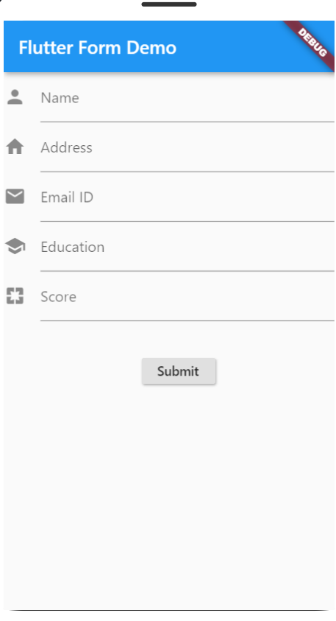

# **Conclusion**

Hence, we were able to implement form validation in flutter.